Functions Day 2 HW Name: ____________________

Find all missing information for the following functions.
1.  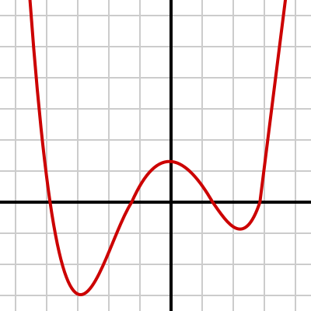  Domain:  Range:  Function/Not Function (circle)  Increasing:  Decreasing:  X – Intercept(s):  Y – Intercept(s): | 2.  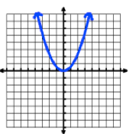  Domain:  Range:  Function/Not Function (circle)  Increasing:  Decreasing:  X – Intercept(s):  Y – Intercept(s): | 3.  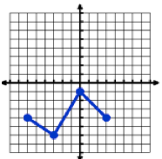  Domain:  Range:  Function/Not Function (circle)  Increasing:  Decreasing:  X – Intercept(s):  Y – Intercept(s):

Functions Day 2 HW Name: ____________________

Find all missing information for the following functions.
4.  (x + 1)(x – 3) = 0  Domain:  Range:  Function/Not Function (circle)  Increasing:  Decreasing:  X – Intercept(s):  Y – Intercept(s): | 5.  X³ – 8x = 0  Domain:  Range:  Function/Not Function (circle)  Increasing:  Decreasing:  X – Intercept(s):  Y – Intercept(s): | 6.  x² + 5x + 6 = 0  Domain:  Range:  Function/Not Function (circle)  Increasing:  Decreasing:  X – Intercept(s):  Y – Intercept(s):

