Understanding Functions
- The relation described by the set of points {(-2,5),(0,5),(3,8),(3,9)} is NOT a function. Explain why.
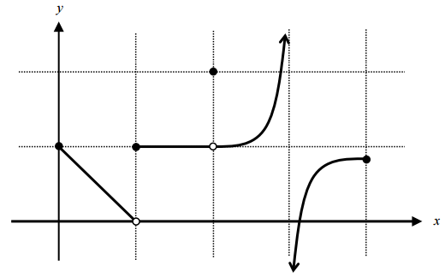
- Explain why the graph represents a function.
- Using interval notation, describe the domain
and range of the function to the right.
- Graph each function in your calculator, then write the domain and range:
a) $f\left(x\right)=\sqrt{x+2}$
b) $g\left(x\right)=x^{2}-6x+3$
c) $k\left(x\right)=x^{3}-2x^{2}+1$
- The given function is only drawn for $x≥0$. Complete the function for $x<0$ with the following conditions:
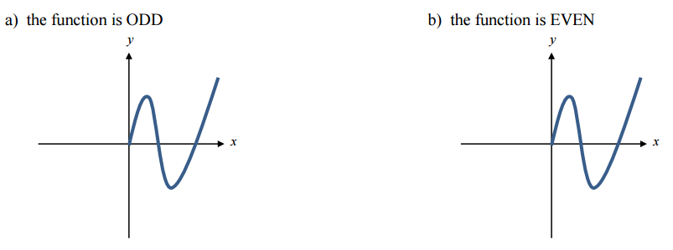
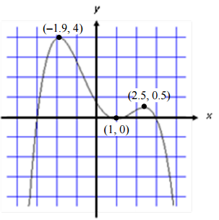
- Suppose you know the point (-2, -10) is on the graph of a function.
a) If the function is ODD, what other point is on the function? __________
b) If the function is EVEN, what other point is on the function? __________
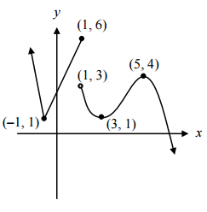
- Use the graph at the right to answer the following questions:
a) Identify all extrema.
b) Identify the intervals on which the function is
increasing and decreasing.
c) Identify the end behavior.
- Use the graph at the right to answer the following questions:
a) Identify domain and range.
b) Identify the intervals on which the function is
increasing and decreasing.
c) Identify the end behavior.
- Use your graphing calculator to graph the function $g\left(x\right)={-x}^{3}+2x-3$.
a) Identify all extrema.
b) Identify the intervals on which the function is increasing and decreasing.
c) Identify all x and y intercepts.
d) Identify the end behavior.

