Station 1: Normal Distribution
1. | 2.
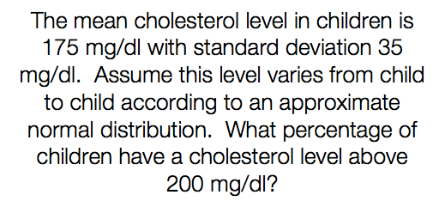 | 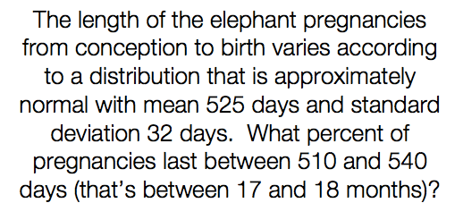
3. | 4.
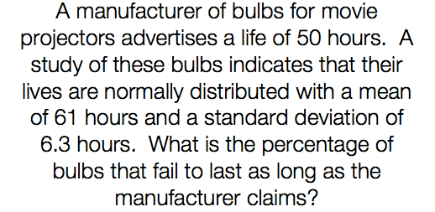 | 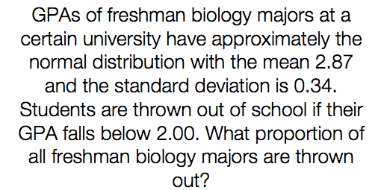

Station 2: Measures of Central Tendency
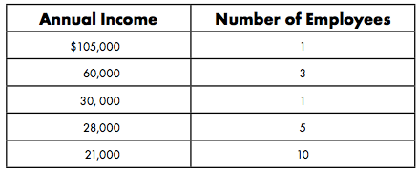

1. Find the mean, median, mode, and range.

2. In negotiations, the owner of the company will probably use the _____________ to describe the company. Why?

3. The union leader (person negotiating for the workers) will probably use the _____________ to describe the company. Why?

4. A statistician would probably use the _____________ to describe the company. Why?

Station 3: Interpreting
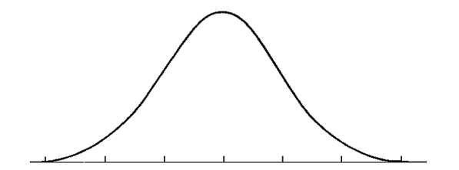
- 2000 sophomores at UNC Charlotte took a physics test. The scores were distributed normally with a mean of 78 and standard deviation of 5. Label the following curve and answer corresponding questions.

- What percentage of scores are between 73 and 83? _____________
- What percentage of scores are less than 68? _____________
- What percentage of scores are between 70 and 77? _____________
- What percentage of scores are greater than 82? _____________
- Approximately how many physics students scored between 78 and 84? _____________
- Approximately how many physics students scored less than 67? _____________

Station 4: Z – Scores
- a.) On a Statistics test, the class mean was 63 and the standard deviation was 7. Calculate the z-score
if you got a 72 on the test.

b.) For the Biology test, the mean was 68 and the standard deviation was 10. Calculate the z-score if
you got a 72 on the test.

c.) For the English test, the mean was 76 and the standard deviation was 8.5. Calculate the z-score if
you got a 72 on the test.

- Compare the results between the 3 tests in Question 1.
- Describe in words what a z-score actually means.

- The scores on a recent test are normally distributed. John’s test score of 65 was 1 standard deviation below the mean. Kristin’s test score of 89 was 2 standard deviations above the mean. What are the mean and standard deviation for the test score distribution?

Station 5: Margin of Error &
Confidence Intervals

- The students in Ms. Smith’s class have obtained the following scores on the state test:
71 70 69 76 68 73 76 72 68 76 68 70

What is the 95% confidence interval for the data?

- In a survey of 2500 high school students, 1952 said they had to purchase some of their own clothes from their allowance. What is the margin of error?

- SENIOR CITIZENS In a survey of U.S. citizens aged 65 and over, an average of 52% said that they participated in activities at their local Senior Citizen Center at least twice a year. The margin of error was 5%.

What does the 5% indicate about the results?

- In an international survey with 4,561 respondents, 46% said that 'coaching or mentoring' has a great impact on career success. Find the margin of error of the survey and the 95% confidence interval.

Station 6: Sampling and Randomization
- A politician wants to know what issues are most important to the voters in his district. Identify the sampling method and state any bias in the method.
Convenience sample | Self-selected sample | Systematic sample

- The politician spends 9:00 am to 4:00 pm on Tuesday talking to people as they enter a grocery store.

- The politician sets up a questionnaire on his website.
- The politician uses the phone book and selects every 50th citizen to call.

- State whether each method would produce a random sample. Explain your reasoning.

  - surveying people coming out of a movie theater to find out people’s favorite entertainment

  - placing a survey in the local newspaper to determine how people voted in the last election

  - selecting students at a school to answer questions by randomly drawing their student identification numbers from a hat

