Station #5 – Similar Triangles
- Find a and b for the two similar triangles:
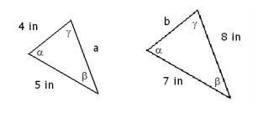
- Consider the picture shown below:
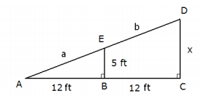
a) Use the Pythagorean Theorem to find the value of a.
b) Prove that the triangles ABE and ACD are similar.
c) Use similar triangles to find the value of x.
d) Find the value of b
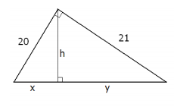
- A person is standing 40 ft away from a street light that is 30 ft tall. How tall is he if his shadow is 10 ft long?
- Find x, y and h (hint, use Pythagorean Theorem):

Station #1 – Parallel and Transversal Lines
- Name the relationship between the measured angle, then find x:
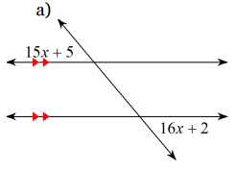 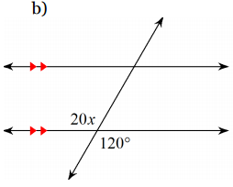 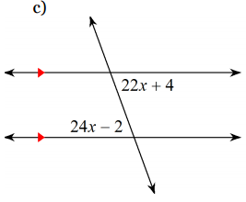
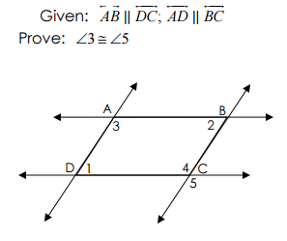
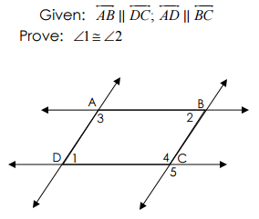
- g 3)

Station #2 – Triangle Proofs (Part 1)
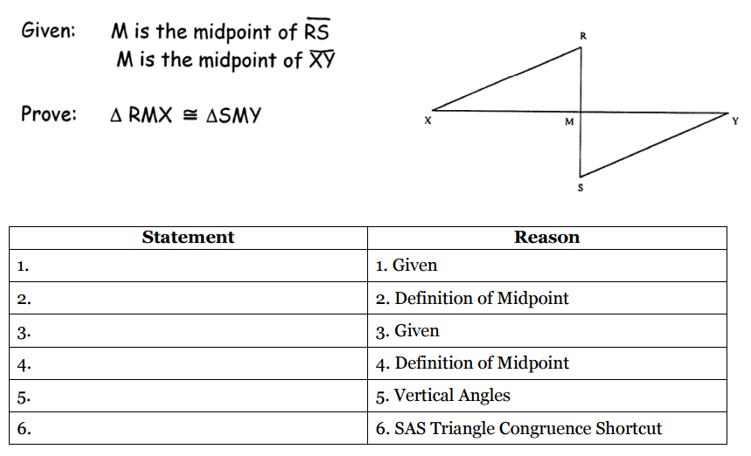
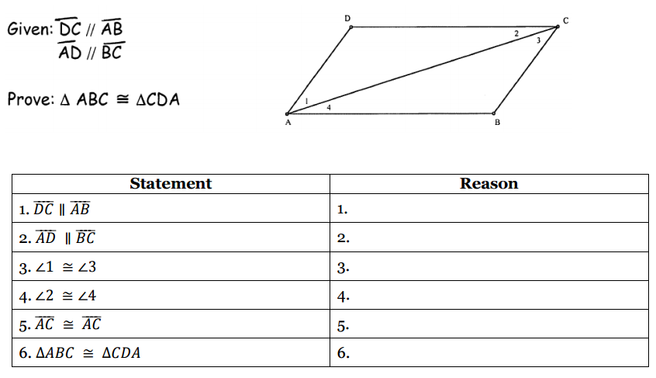
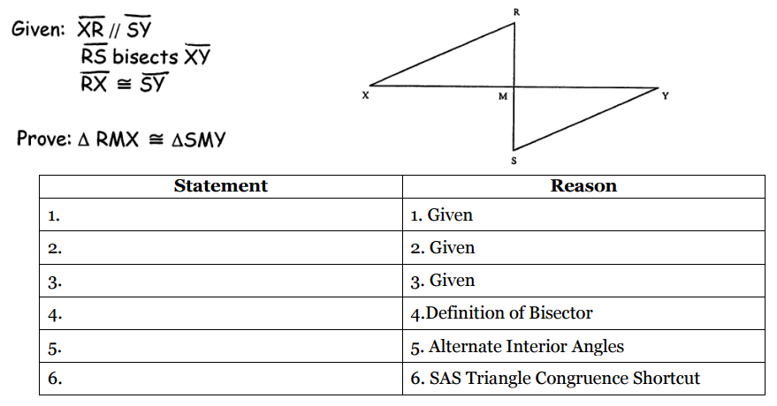

Station #3 – Triangle Proofs (Part 2)
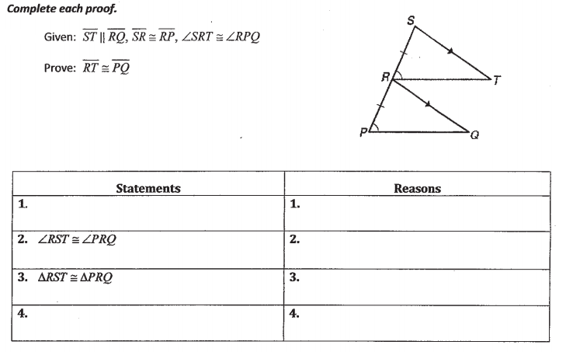
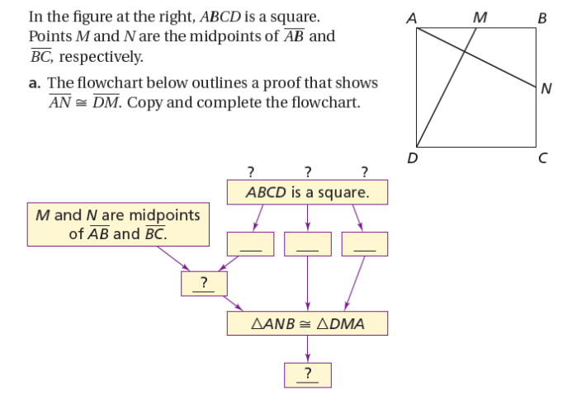
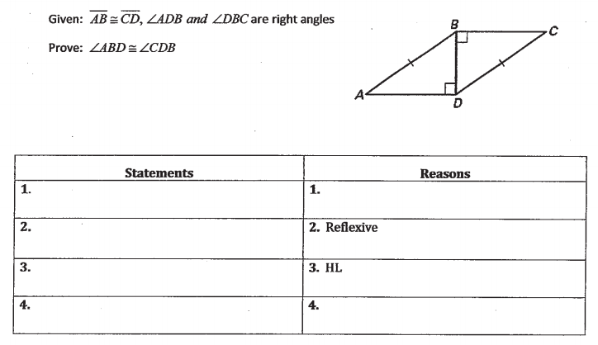

Station #4 – Parallelogram Proofs
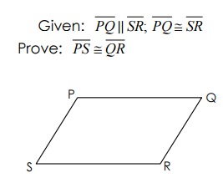
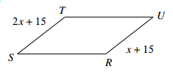
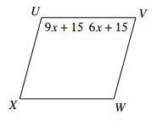
- Solve for x:
a) b)
