Geometry Ornament
The ornament you are going to make is a polyhedron called an icosahedron. It will wind up being a geodesic sphere made up of twenty flat triangular sides. It is actually made with circles. The fun part comes in changing the circles into the equilateral triangles that form the shape.
Materials: To construct the ornaments you will need colored paper, pencil, compass, scissors and glue
- You need to use the compass and draw 20 congruent circles. They can either be 2”, 3” or 4” circles. If you need help on how to use the compass, then go to my website and watch the video attached to this day ().
- Cut out a circle. Fold over the edge of the circle until its circumference touches the center point made by the compass point. Crease the fold sharply. Rotate the circle and fold another edge inwards so that the circumference touches the center point and the corner of this fold meets the corner of the previous fold. Now fold the remaining edge of the circle over to make a triangle shape. Repeat these steps with the remaining circles
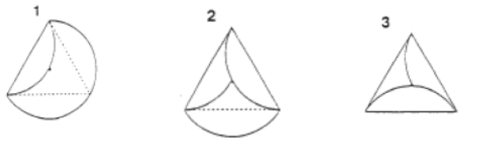
- Using glue or a stapler, join the flaps of five circles together to form a little hat. Repeat this step with five more circles to make a total of two hats.
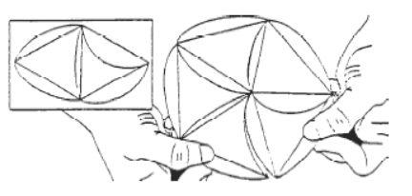
- Join the ten remaining circles together to make a long line of triangles. It may help to draw a straight line on a piece of paper and align the edges of five triangles along the line. Then insert five more triangles into the openings between the first five triangles.
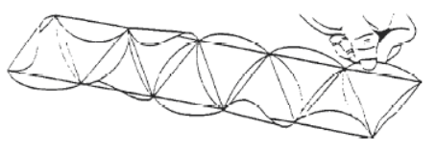
- Bring the two free ends of the chain of triangles together to make a ring. You will know you have done it right if there are five free flaps on the top of the ring and another five on the bottom.
Now attach the flaps on one cap with the flaps on the top of the ring and glue or staple them together. Do the same with the remaining cap and flaps on the bottom of the ring. You have made an icosahedron (as well as an interesting ornament or decoration).
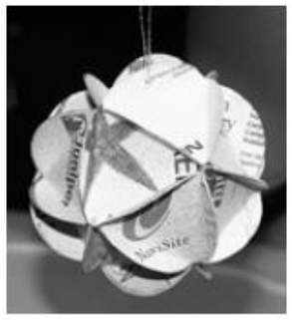
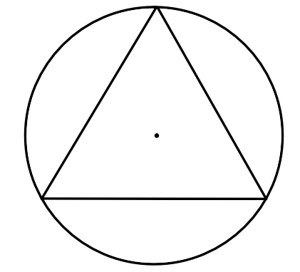
Directions: Answer the following questions about your ornament. Make sure to show ALL possible work for full credit.
- a) What was the radius you chose? __________
- Label the inscribed angles (made by the triangle) to
the right with their proper measurements.
- Label the measurements of the arcs which are
separated by the inscribed angles.
- Draw a central angle that includes one of the 3 arcs.
- Label the measurement of your central angle.
- Using the radius you chose for your circle, answer the next set of questions:
a) What is the area of the circle?
- What is the area of the sector that was made by the central angle?
- What is the area of the same sector if the central angle was decreased by 20 degrees?
- What is the circumference of your circle?
- What is the arc length of your sector?
- If the central angle was increased by 13 degrees for the sector, what is the new arc length?
- Answer the following if your circle was located on the coordinate plane with the center at (-1, 2)
- Write the standard form equation of your circle: ________________________
- Write the expanded version of your circle equation (multiplied out).
- Complete the square to condense your equation back to standard form.
- Would your circle touch the point (-3, 5.46)? Verify your answer.
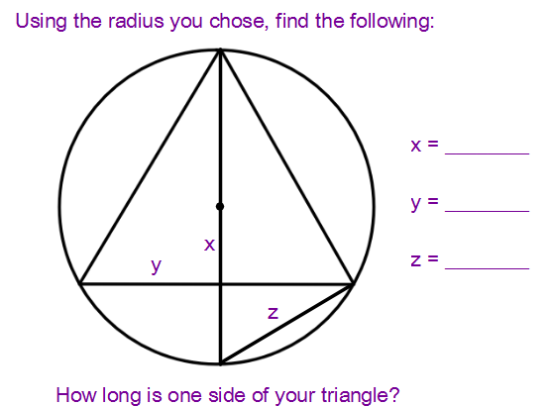
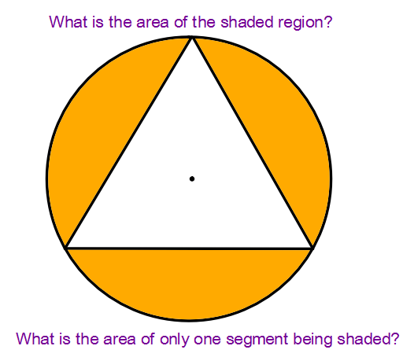
4. 5.

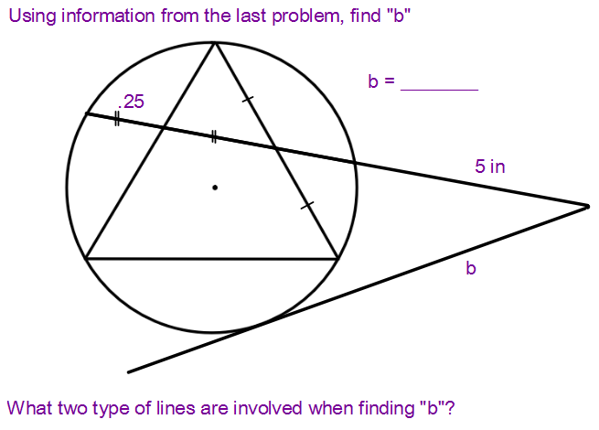
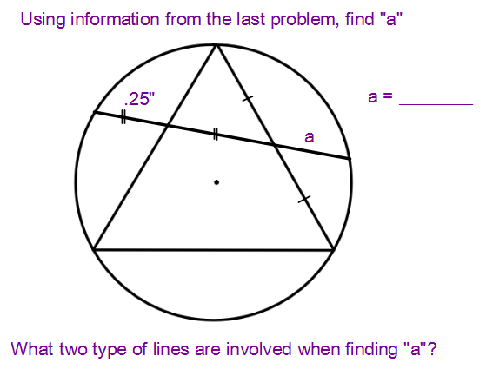
6. 7.
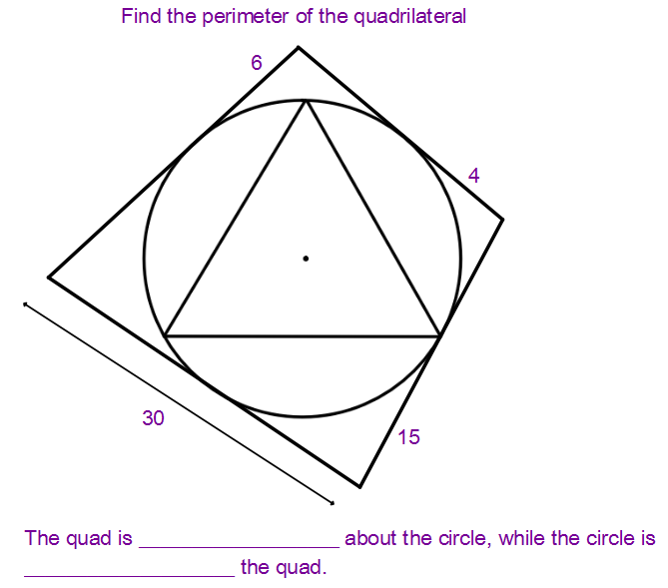
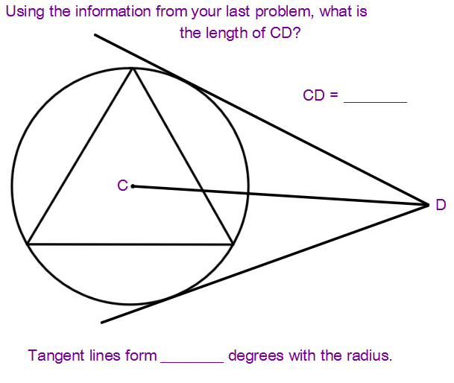
8. 9.

10. Conclude by answering the following:
a) What is the surface area of the ornament?
b) If your ornament was a perfect sphere, what would be its volume?
c) If you inverted your ornament (to where the flaps were on the inside), what would be the difference between the two surface areas?

